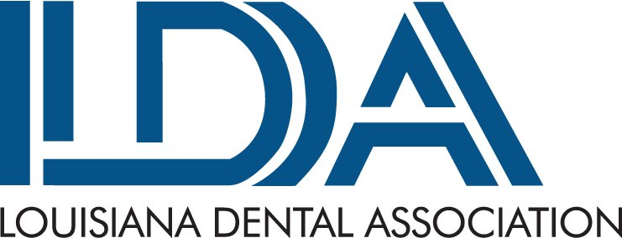

Radiographic Online Course Order Form

Date: (Please Print Clearly as this will be used to LOGIN.)

Name of person(s) taking the course 1. 2.
(As the name should appear on Certificate) 3. 4.
5. 6.
7. 8.

School/Academy Name and Mailing Address, if applicable:

_______________________________________________________________________________________
Contact Person’s Name: _____________________ Telephone Number: _____________________
Email Address: ______________________________

Sponsoring Dentist’s Name: ________________________________
Sponsoring Dentist’s Mailing Address: _____________________________________________________
Fee includes cost of the online course and certificate of completion.
LDA Member Dentist $50.00
LDA Non-Member Dentist $125.00

Additional Online Course for Groups
LDA Member – each additional course participant is $25.00 $_____.00
Non-Member - each additional course participant is $50.00 $_____.00

Radiographic Course Total Due: $______.00

Payment (Select Payment Option)
Check - payable to LDA; mailed to 5637 Bankers Ave; Baton Rouge, LA 70808

Credit Card - add 3% credit card convenience fee to the total purchase amount for each credit or debit card transaction.

**We accept Visa, MasterCard, American Express and Discover**
Name (as it appears on card): _______________________________ Expiration Date: ___________

Credit Card #: __________________________________ CVC: _________ Zip Code:__________

Total Credit Card Charge (includes 3% convenience fee): $________

Email request form to Amber@ladental.org or call (225) 926-1986

