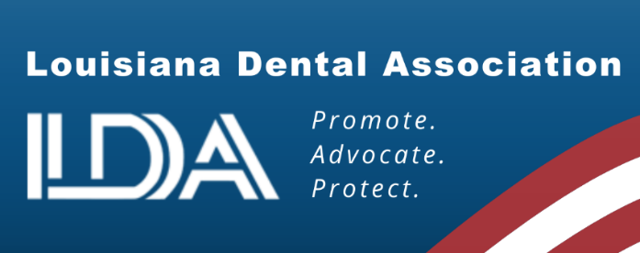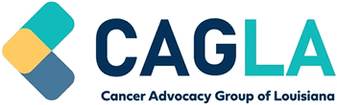

SUPPORT SB 155 by Senator Kirk Talbot:
Coverage for Certain Dental Procedures
Prior to Cancer Treatment

SB 155 would provide insurance coverage for treatment clearance and basic extractions that are medically necessary for an insured diagnosed with cancer. If a patient cannot access these dental procedures that are necessary to avoid infection, it can prevent patients from receiving life-saving cancer treatment. A patient cannot undergo treatments such as chemotherapy or radiation therapy with the risk of any type of infection being present, including current or potential dental infections.

The average cost of cancer treatment can vary significantly based on the stage of the disease, the type of treatment, and the patient's insurance coverage, however it is not uncommon for insurance to cover upwards of $100,000 or more for cancer treatment. The medically necessary dental treatment is minimal compared to all of the extensive cancer treatment costs.

The doctors’ goals are typically to save the patient and provide treatment to restore their lives to a reasonable and healthy phase. Extractions should not be the barrier to cancer care.

Can you imagine this scenario? You are diagnosed with cancer and cannot start any treatment due to the fact that you have a few teeth that need to be removed. However, you cannot afford to pay for the extractions, so you delay getting the cancer treatment that could save your life.

Bottom line, this bill was filed by cancer patient advocates who understand the importance of providing life-saving treatment and helping cancer patients achieve their best outcomes.

Please Vote YES on SB 155

The mission of the LDA is to promote, advocate, and protect the dental profession. The LDA membership represents approximately 75% of the dentists in Louisiana. For more information, call Annette Droddy at the LDA at (225) 926-1986 or email annette@ladental.org.

