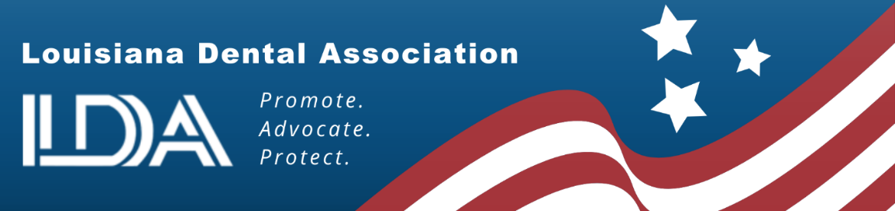

SUPPORT SB 192 by Senator Franklin Foil:
Giving Dentists Choice in Reimbursement Methods

In recent years, insurance companies have started paying healthcare providers using electronic payments, including virtual credit cards. A virtual credit card works much the same as a physical credit card except that the insurance company issues a single-use series of numbers instead of a card, and the provider then enters the numbers into a credit card terminal or web portal to get payment transferred to his/her designated account. Sounds easy enough, right? Until you consider the fees…..

Like any other credit card transaction, the merchant receiving the payment incurs a processing fee, which can range from 2.5-5% on the underlying charge. This means that whenever a provider is reimbursed this way by an insurance company, 2.5-5% is automatically subtracted from that reimbursement payment. So, if a practice received total reimbursements of $1,000,000/year all via virtual credit card payments, that is an automatic expense of $25,000-50,000/year for that practice. (That’s on top of accepting payment that’s often more than 30% LESS than the dentist’s usual fee.)

The National Council of Insurance Legislators (NCOIL) studied this concept and agreed on model legislation and the LDA passed that legislation in 2019. It allowed dental offices to opt out of the virtual credit card system and choose alternate methods of payment. After monitoring its success, NCOIL in 2025 amended the model to suggest that dentists automatically are opted out of the virtual credit card and they have to opt in if they choose to accept that method of payment.

Since the LDA had received notice from dentists that several dental insurance companies were requiring yearly opt out of the virtual credit cards, SB 192 was filed in response to NCOIL’s updated model legislation.

SB 192 is not about patient payments. It is about how insurance carriers pay the dentist. Many dental offices across Louisiana are small businesses with tight bottom lines! They are doing their best to hold down unnecessary and burdensome costs so that they don’t have to pass that on to their patients. In some cases, the carrier actually receives a share of the revenue generated from these transaction fees.

Bottom line – the dentist accepts a fee schedule from an insurance carrier that is at 70% of their normal rates and if they are forced to accept a virtual credit card, they would lose up to another 5%. Let’s simplify the process for these small businesses. Support this legislation and they can opt in if they want to be paid via a virtual credit card!

Please Vote YES on SB 192

The mission of the LDA is to promote, advocate, and protect the dental profession. The LDA membership represents approximately 75% of the dentists in Louisiana. For more information, call Annette Droddy at the LDA at (225) 926-1986 or email annette@ladental.org.

